Activity sheet – Fire-stick farming
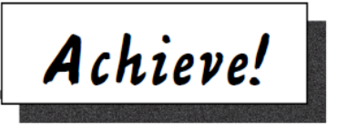

Biodiversity and fire-stick farming
1 Draw a line to match the beginning of each sentence about biodiversity and
fire-stick farming with its ending.
Sentence beginnings | Sentence endings
Living things are plants, animals, | they are less destructive.
An ecosystem is a group of living things that live | making more room for native plants.
In the word biodiversity, ‘bio’ means life and ‘diversity’ means different. So biodiversity means all the | together in an area that produces everything they need to survive.
Ecosystems are made up of lots of habitats. A habitat is | found anywhere else on earth.
A place with lots of different types of living things and ecosystems has | growth, which different types of animals can live in.
Seven per cent of the world’s living things are found in Australia and many of them are not | the place where an animal or plant lives.
The best way to protect Australian biodiversity is to | different types of living things and the ecosystems they live in.
Regular small, early fires are better for Australian biodiversity than rare, large, hot fires later in the season because | fungi and micro-organisms.
Fire-stick farming creates a mosaic of habitats. This means there are patches of plants at different stages of | more biodiversity than a place with only a few different types.
Fire-stick farming helps to control weeds by burning them away, | look after ecosystems and habitats.

